A scope for research methodology exams
Semester 2 – Week 1
What is research paradigm -> a research paradigm is the philosophical worldview or a belief system of a researcher’s understanding of reality and knowledge, ultimately shaping every stage of the research process. It resolves how research questions are established, how data is collected, and finding are interpreted.

The key paradigms that commonly used in research:
- Positivism: it assumes that reality is objectives and can be measured through observable and quantifiable facts. It characteristically uses statistical and numerical data in controlled and experimental environments. E.g IT research evaluating a speed performance of two different algorithms may adopt this approach.
- Interpretivism: it recognizes the value of individual’s subjective experiences and perceptions. It is useful to explore complex human behaviours and social phenomena. E.g research that explore how experienced software developers experience debugging could utilize interpretivism lens.
- Pragmatism: is an adaptable and problem-centred paradigm. It aims to achieve a practical outcome and may employ a combination of quantitative and qualitative methods to address the research objectives. E.g. a study could utilise quantitative data from system usage logs and combine it with qualitative data from user feedback interviews to evaluate the effectiveness of a learning management system.

Three research approach:
- Quantitative approach: this approach uses numerical data to test hypotheses. E.g. statistical data can be used to evaluate system load times across multiple servers.

- Quantitative approach: explores phenomena through detailed narrative. E.g. interviewing software developers about their experiences with agile methodology.

- Mixed approach: combines both quantitative and qualitative approaches. .g. using a survey to assess usability issues in a mobile app, followed by interviews to explore the reasons.

Research methodology:
- It is the overall plan and process that directs how a research study is conducted.
- It involves a systematic choice a researcher makes regarding what type of data to gather, how to gather it, who to gather it from, and how to analyse it to address the research questions.
- It’s a systematic journey towards finding answers to research questions.
- Includes a clear justification for each decision, whether it's selecting interviews over surveys or statistical analysis over thematic coding, by demonstrating how the methods align with the research aims and questions.
- While research design refers to the overall framework of the study (e.g., experimental, case study, or ethnographic), research methodology focuses on the detailed procedures and techniques used to implement that design effectively.
- Acts as the link between your research questions and the evidence you collect.
- It guarantees that your investigation remains logical, cohesive, and credible so that your findings are reliable and your conclusions are well-supported.

Quantitative research designs:
- Descriptive: This type concentrates on detailing existing conditions, behaviours, or characteristics by systematically collecting information without manipulating variables. In other words, the researcher does not intervene, only collects data.
- Correlation: This type aims to identify and measure the relationship between two or more variables without manipulating them. In other words, this type of research design is useful when you want to know whether a change in one thing tends to be accompanied by a change in another.
- Experimental: This type is used to establish whether a cause-and-effect relationship exists between two or more variables. In this research design, you, as the researcher, manipulate one variable (the independent variable) while controlling others (dependent variables). It helps you see how the independent variable affects the dependent variable, allowing you to draw conclusions about possible causality.

Qualitative research designs:
- Phenomenological: It examines the significance of lived experiences and personal perceptions. It aims to understand people’s perspectives, emotions, and behaviours in specific contexts to capture the core of human experience without allowing assumptions or preconceptions to influence their understanding.
- Grounded theory: It aims to develop theories through ongoing, repetitive analysis and comparing data gathered from a large group of participants. It uses an inductive (bottom-up) approach, emphasizing allowing the data to 'speak for itself' without being influenced by preexisting theories or the researcher’s assumptions
- Ethnographic: It involves observing and studying a group of people sharing a common culture in their natural environment to gain a better understanding of their behaviours, beliefs, and values. The focus is on watching participants in their authentic surroundings rather than in a controlled setting. E.g To explore the cultural and social dynamics of contributors in open-source software communities.
- Case study: The researcher investigates a single individual (or a single group of individuals) to understand their experiences, behaviours or outcomes. Unlike other research designs that are aimed at larger sample sizes, case studies offer a deep dive into the specific circumstances surrounding a person, group of people, event or phenomenon, generally within a bounded setting or context. E.g. To explore the factors influencing the adoption of an information system in a specific small business.

Semester 2 – Week 2
Designing Data Collection Methods for Qualitative and Quantitative Research

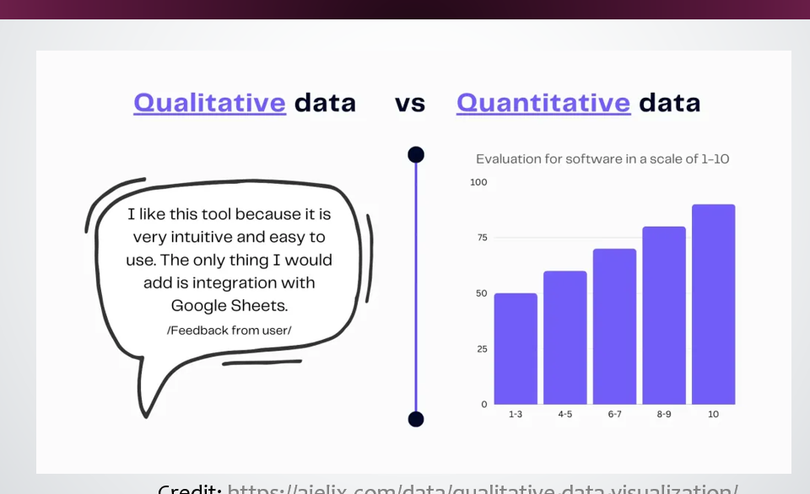

- Quantitative methods are effective for measuring patterns, frequencies, and the relationships between variables. The data gathered is numerical and analysed using statistical methods, making it easier to find meaningful insights.
- Qualitative methods are well-suited for exploring lived experiences, perspectives, and meanings. They are more flexible and employ open-ended questions that invite detailed and thoughtful responses. The resulting rich data is typically in text form and is often analysed through thematic or narrative approaches, facilitating the uncovering of deeper insights.

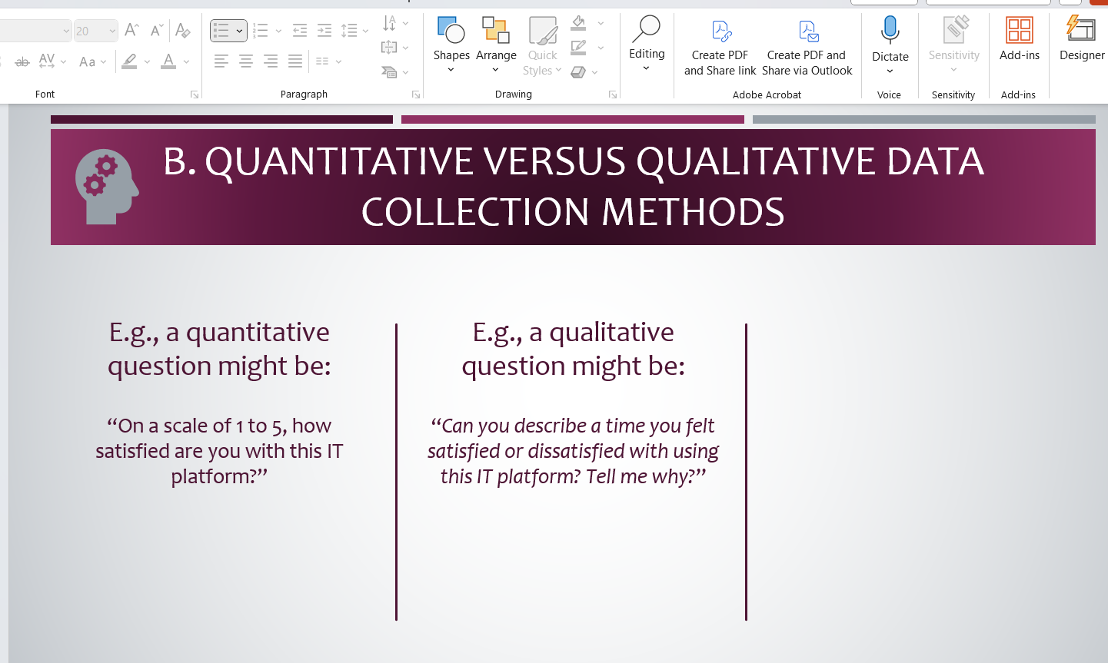

General considerations for the design of data collection methods:

- Clarity: Questions should be easy to understand and free from jargon. Respondents should interpret questions in the same way.
- Relevance: Each question should relate directly to the research objectives.
- Sequencing: Questions should follow a logical order, usually starting from general to more specific.
- Ethical Sensitivity: Instruments must be designed in a way that respects respondents’ privacy and emotional comfort.
- Cultural Appropriateness: Language and content should be suitable for the context and audience.
- Pilot Testing: Instruments should be pre-tested with a small sample to identify and correct any issues before full deployment.

Designing quantitative data collection methods:
- Avoiding Complexity and Ambiguity: Quantitative questions must be clear and specific to avoid misinterpretation. Vague or confusing questions result in unreliable data.
- Avoiding Double-Barrelled Questions: Questions that ask about more than one issue at once make it difficult for respondents to answer clearly. Example:
“Do you agree that online learning is cost-effective and efficient?”
This should be split into two separate items to get more accurate responses.
a. “Do you agree that online learning is cost-effective?”
b. “Do you agree that online learning is efficient?”
- Ensuring Exhaustiveness and Mutual Exclusivity: Closed-ended response options should cover all possible answers (exhaustiveness) and should not overlap (mutual exclusivity).
- Using Balanced and Consistent Scales: Likert-type items should consistently use the same scales throughout the instrument to prevent confusion.
- Preventing Respondent Fatigue: A long, repetitive, or poorly organized questionnaire can lead to incomplete answers or disengagement. Only include questions directly linked to the research objectives.

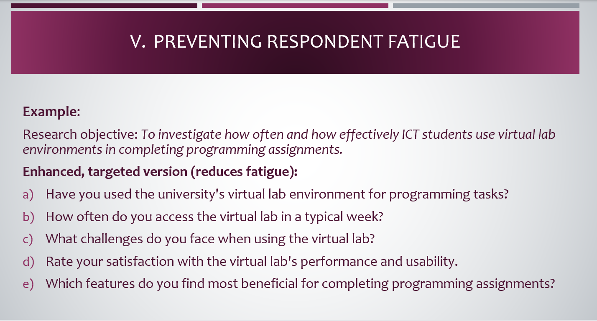

- Contribution to Data Analysis Plan: Every question should align with the research objectives and be carefully chosen to contribute directly to the final data analysis.
- Standardizing Responses: Ensure common terms and scales are used to avoid confusion.

Designing qualitative data collection methods:

When planning to gather qualitative data, researchers must shift their focus from fixed response questions to open-ended formats that foster rich, detailed explanations. Unlike quantitative methods, which measure frequency or magnitude, qualitative methods aim to understand experiences, perceptions, and meanings.

- Crafting Open-Ended Questions: Good qualitative questions begin with words like how, what, or why, and avoid yes/no answers. They are designed to explore rather than measure.
- Using Probes and Follow-Up Questions: One of the strengths of qualitative data collection, particularly in interviews and focus groups, is the ability to probe more deeply. This involves asking follow-up questions based on the participant’s initial response to gain a more comprehensive understanding.
- Maintaining a Neutral and Respectful Tone: It is essential that questions are non-leading, implying a specific answer. Participants should feel safe, respected, and free from judgment when expressing their views.
- Using an Interview or Discussion Guide: A qualitative data collection method typically appears as an interview schedule or focus group guide, which comprises:
  - A short list of key themes or questions
  - Space for probes
  - Reminders about tone, ethical considerations, and consent
- Ethical Sensitivity and Contextual Awareness: Participants should feel at ease discussing even sensitive topics, such as inequalities in access to technology or digital stress. Ensuring confidentiality and fostering a welcoming environment promote honest and valuable responses.

Semester 2 – Week 3
Sampling
- Random Sampling: You roll a die or use a random number app to select ticket holders to interview. Everyone has an equal chance.
- Stratified Sampling: You divide fans into groups (e.g., by ticket section or age) and sample from each group proportionally.
- Convenience Sampling: You talk only to the first 20 fans you see. This is easiest but also riskiest.
- Purposive Sampling (common in qualitative research): You choose particular fans, maybe those wearing player jerseys or carrying banners, because they’re more likely to give rich opinions.
Understanding that sampling is the process of selecting a subset of individuals or units from a larger population to make inferences or understanding about that population is important in research.
In quantitative research, the goal is to choose a sample that is unbiased and accurately represents the population from which it is drawn.
In qualitative research, sample selection may be influenced by factors such as ease of access to respondents, the researcher's judgement that the individual has extensive knowledge about a relevant topic, event, or situation or simply that the case is markedly different from others.
As Kumar (2011) explains, probability sampling improves generalisability, while non-probability sampling allows for in-depth exploration when the population is unknown or difficult to access.

Semester Two - Week 4
Data Management and Ethical Considerations in Research
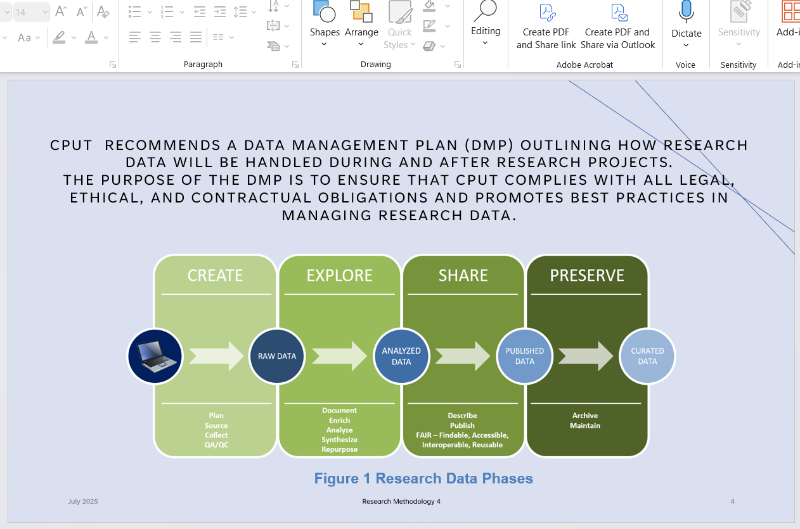

Create Stage:
Activities involved with the creation (Raw Data Generation) of research data include:
- Plan: Define research objectives and methods.
- Source: Identify tools and data platforms.
- Collect: Gather primary data.
- QA/QC: Conduct quality assurance and control.
Example:
In ICT, students might collect user interaction logs from an e-learning platform or run an app that tracks system performance.

Explore Stage:
Activities involved with the exploration (Data Processing and Analysis) of research data include:
- Document: Record methods and metadata.
- Enrich: Add contextual data.
- Analyse: Interpret data using statistical or qualitative tools.
- Synthesise: Integrate different data sources.
- Repurpose: Consider secondary use of data.
Example:
ICT researchers might analyse mobile app analytics to understand usage patterns or compare feedback with backend logs.

Sharing Stage:
Activities involved with the sharing (Dissemination and Access) of research data include:
• Describe: Create metadata.
• Publish: Share in repositories or with publications.
• Follow FAIR principles: Ensure data is Findable, Accessible, Interoperable, and Reusable.
Example:
Publishing anonymised survey datasets from a usability study in an open repository, or sharing code on GitHub.

Preserve Stage:
Activities involved with the preservation of research data include:
• Archive: Deposit in institutional/national archives.
• Maintain: Update and use open formats for accessibility.
Example:
Preserving IoT sensor data from a smart classroom for future research or storing interview transcripts with permanent identifiers.

The Research Data Lifecycle illustrates that research data is a critical research output requiring ongoing attention throughout a research project’s lifecycle. From planning and collection to sharing and archiving, each stage supports transparency, reuse, and the long-term value of research. It also aligns with global trends promoting open science, data sharing, and robust data stewardship.

Principles of research ethics
